Streptococcus pneumoniae
You may be wondering what Streptococcus pneumoniae is and why I chose this microbe for my wiki. Streptococcus pneumoniae, commonly referred to as the pneumococcus, is a Gram-positive bacterium which is dangerous because it can cause pneumonia, bronchitis, otitis media, septicemia, and meningitis. There are a few techniques for identifying Streptococcus pneumoniae, one of which is an assay based on detection of S. pneumoniae specific DNA sequences.^{[1]} This caught my eye since we just read about this in our newly assigned chapters.
I was interested in this topic for quite a few reasons, but one of the reasons I wanted to research this microbe was because my grandfather has respiratory issues and was recently diagnosed with lung cancer. Although he is not suffering from Streptococcus pneumoniae I thought it would be beneficial to learn more about the respiratory tract to understand more of what he is struggling through. And S. pneumoniae and lung cancer do share some microbial associations it is stated in the NCBI article that Streptococcus, Enterococcus, and Granulicatellaare anaerobes and the detection of Veillonella as an anaerobe would be enough to argue that lung cancer is associated with a switch to anaerobic fermentative respiration.^{[2]}
Streptococcus pneumoniae can be carried by many people and not cause that person to become ill. However, some people such as the elderly, unvaccinated children, or immunocompromised persons are most at risk. With this being said some people contract the infection for no apparent reason. These bacteria are spread from person to person via droplets that are produced by the infected person in which the uninfected individual breathes in. ^{[3]}
Infections caused by these bacteria, as stated in the paragraph, above spread via droplets from person to person. The bacteria enter the nasal cavity and attach to nasopharyngeal epithelial cells then they either stay as a colonizer or spread to other organs. These organs include the lungs via bronchi, the ears, and the sinuses. Which then can potentially penetrate the mucosal barrier and enter the blood stream.^{[5]} This is represented in the figure below. ^{[4]}

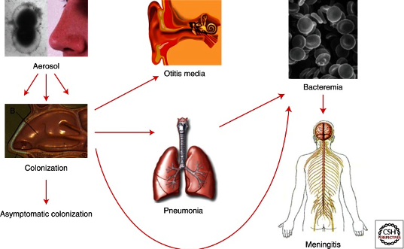

S. pneumoniae Transmission ^{[4]}

For S. pneumoniae the signs and symptoms are dependent upon the part of the body affected. The signs and symptoms that are typically present include fever, chills, irritability. Others that may appear are headache, stiff neck, confusion, fatigue, and vomiting. After exposure symptoms usually occur within one to three days after exposure. However, the incubation period varies with each infected individual. ^{[3]}
Streptococcus pneumoniae is a very dangerous disease if contracted it is not something that should ever be taken lightly. The pneumococcus is a highly invasive, Gram-positive, extracellular bacterial pathogen and a major cause of morbidity and mortality globally causing more deaths than any other infectious disease. This Gram-positive bacterium can cause pneumonia, bronchitis, otitis media, septicemia, and meningitis. Researching this microbe really deepened my knowledge of the bacteria Streptococcus pneumoniae and hopefully this wiki can help others learn about this microbe as well.

References
- Fleck, O. (2019, February 27). Streptococcus pneumoniae (pneumococcus): Overview. Accessed 10 July 2020, <https://www.news-medical.net/health/Streptococcus-pneumoniae-(pneumococcus)-Overview.aspx>
- Mur, L., Huws, S., Cameron, S., Lewis, P., & Lewis, K. (2018, September 5). Lung cancer: A new frontier for microbiome research and clinical translation, accessed 10 July 2020, <https://www.ncbi.nlm.nih.gov/pmc/articles/PMC6145518/>
- Home. (n.d.). (2018, October). Streptococcus pneumoniae Invasive. Accessed 18 July 2020, <https://www.vdh.virginia.gov/epidemiology/epidemiology-fact-sheets/streptococcus-pneumoniae-invasive-infection/>
- [Digital image]. (n.d.). (2013, July). The Pneumococcus: Epidemiology, Microbiology, and Pathogenesis. Accessed 18 July 2020, <https://www.ncbi.nlm.nih.gov/core/lw/2.0/html/tileshop_pmc/tileshop_pmc_inline.html?title=Click%20on%20image%20to%20zoom&p=PMC3&id=3685878_cshperspectmed-BAC-010215_F1.jpg>
- Henriques-Normark, B., & Tuomanen, E. (2013, July 1). The pneumococcus: Epidemiology, microbiology, and pathogenesis. Accesses 18 July 2020, <https://www.ncbi.nlm.nih.gov/pmc/articles/PMC3685878/>

